
The FAN Charity
Sickness and Absence Policy

The FAN Charity understands that from time to time there may be various reasons why you need to be absent from work and wishes to assist you with this where possible within the needs of the organisation. This policy covers all employees of the FAN Charity including part-time staff and those on fixed-term contracts. The reason for setting out the details of each type of absence, including sickness, is to ensure that all employees understand their entitlements, and to ensure consistency is applied to all requests.
The FAN Charity aims to ensure that if you are absent through illness or injury you will be treated in a fair and reasonable manner, whilst ensuring that the services provided are able to continue at all times. This policy sets out the procedures to be followed if you are absent through illness, including your responsibilities.
In adopting this policy, an element of responsibility is also placed on staff not to abuse sickness absences and to follow the procedures below. If you do not follow these procedures, it may be treated as a disciplinary offence.
Procedure
If you are unexpectedly late or prevented from coming to work for any reason, you must comply with the following procedure:
- you must contact your line manager or Chair of Trustees by 10am, or as soon as possible on the first day to explain the reason for your absence. When notifying your manager of an absence due to sickness, you should indicate the date on which the illness commenced, the nature of the illness and if possible, the date you expect to resume work. If your absence continues after the first day, you must keep your line manager informed and are expected to phone in on each day of absence, unless agreed otherwise with your line manager.
- For periods of sickness greater than 3 and less than 7 calendar days, you must complete and print a self-certificate: https://www.gov.uk/guidance/ask-your-employer-for-statutory-sick-pay
- This should be given to your manager on your return to work or, if you are absent for longer than 7 days, can be completed and returned by post
- For periods of sickness of more than 7 calendar days you must provide a medical certificate ‘fit note’ from your GP or a hospital doctor and send it to The FAN Charity, c/o 29 Park Avenue, Whitchurch, CF14 7AL.
- For periods of absence longer than 7 calendar days, continue to send in consecutively dated medical certificates as necessary and keep your line manager informed on a regular basis.
- If the absence is more than 7 calendar days, on your return to work your line manager will complete a return to work interview. This should be done on your first day back at work, or as soon as possible thereafter.

Sickness during holiday
If you fall ill immediately before or during an agreed period of annual leave you must follow the normal sickness reporting procedure as set out above. It is accepted that, if you are abroad during the sickness, it might not be possible to notify your manager immediately, but every effort should be made as soon as possible. Any days of sickness during a time of booked holiday will be counted as sickness absence and not holiday.
STATUTORY SICK PAY (SSP)
SSP is payable from the first qualifying day of absence. (A qualifying day is a day on which you are normally expected to work under your contract of employment). FAN will inform the organisation processing staff pay if an employee is sick, the dates of sickness, and days of week regularly worked that have been missed. The organisation paying staff on behalf of FAN will arrange SSP to be paid from the FAN charity account.
The FAN Charity is responsible for making SSP payments for any period (or 'linked' period) of incapacity for work: which lasts for 4 consecutive calendar days or longer; up to a maximum of 28 weeks; where linking occurs - if there are 8 weeks (56 calendar days) or less between two such absences; and no linked period can run for more than 3 years.
Where concerns over your health arise whether you are at work or absent due to ill health The FAN Charity will seek your permission to have an independent medical opinion or an opinion from your GP. The purpose of this is to enable the FAN Charity to understand the diagnosis and prognosis of your ill-health, in order to support you to make decisions about your work.
You will be required to give your consent to a request for medical information because in the absence of this information about your condition, it is difficult to make informed decisions. Once the report is available, the FAN Charity will discuss it with you, and if appropriate, consideration will be given as to whether suitable alternative work or other adjustments are available.

Reviewed by FAN Charity: Working Group: Policies: Staffing, 12.8.26.
Adopted by Trustees: 1.9.26

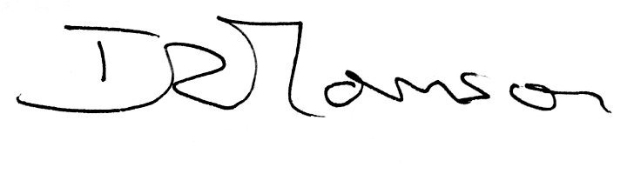
Signed:

Ian Thomson Role: Chairman
Date: 1.9.26

