
The FAN Charity
Code of Conduct

Introduction
The FAN Charity expects all staff of our organisation, regardless of role, to uphold the conduct expectations listed within our code.
Personal behaviour
Staff will be polite and considerate towards others at all times. Respectful of difference and showing no favouritism.
Discipline
Misconduct will be dealt with through our disciplinary procedure.
Safety
Staff will be mindful of safety and protective of others. They will take care of the materials, resources, premises of the organisation.
Dress code
Staff will wear attire that is appropriate for the role or the task in hand, and not provocative or likely to cause offence to others.
Communication
Staff will use appropriate language and tone. They will consider a range of communication methods in order to be accessible to all service users, staff and volunteers.
Confidentiality
Staff will maintain high levels of confidentiality regarding personal information on participants, staff, volunteers and internal details about the organisation.
Safeguarding
Staff will adhere to our Safeguarding Policy and Procedures.
Security
Staff will adhere to FAN’s Health and Safety policy and procedures. Be careful of the safety of themselves and others; follow venue procedures; challenge strangers with courtesy, alert senior staff with any concerns regarding people or premises security.
Fit for work
Do not present yourself for volunteer duties in an unfit condition due to the use of alcohol, prescription or recreational drugs.
Reviewed by FAN Charity: Policies, 12.8.26
Adopted by FAN Trustees: 1.9.26
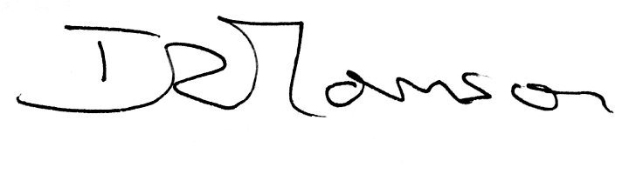
Signed:

Role: Chairman of Trustees Date: 1.9.26

