

**The FAN Charity – Policies**

**Conflict of Interest Policy**

All staff, volunteers, and Trustees of the FAN Charity will strive to avoid any conflict of interest between the interests of the Organisation on the one hand, and personal, professional, and business interests on the other. This includes avoiding actual conflicts of interest as well as the perception of conflicts of interest.

The purposes of this policy are to protect the integrity of the Organisation's decision-making process, to enable stakeholders to have confidence in the organisation’s integrity, and to protect the integrity and reputation of volunteers, staff and Trustees.

Examples of conflicts of interest include:

1 A Trustee who is related* to a member of staff and there is decision to be taken on staff pay and/or conditions at a committee meeting.

2 A Trustee who is also on the committee of another organisation that is competing for the same funding.

3 A Trustee who has shares in a business that may be awarded a contract to do work or provide services for the organisation or is a director, trustee, partner or employee or related to someone who is*.

Upon appointment each Trustee will make a full, written disclosure of interests, such as relationships, and posts held, that could potentially result in a conflict of interest. The declaration will be completed annually by Trustees, noted in the following Trustee meeting and kept confidentially on file while the trustee is in post to evidence compliance with the regulatory requirement.

In the course of meetings or activities, Trustees will disclose any interests in a transaction or decision where there may be a conflict between the organisations’ best interests and the Trustee’s best interests or a conflict between the best interests of two organisations that the Trustee is involved with. If in doubt the potential conflict must be declared anyway and clarification sought.

This policy is meant to supplement good judgment, and staff, volunteers and Trustees should respect its spirit as well as its wording.

* A relative may be a child, parent, grandchild, grandparent, brother, sister, spouse or civil partner of the Trustee or any person living with the Trustee as his or her partner

Reviewed by FAN Charity: Finances: Core Funding, February 2024

Adopted by FAN Trustees:

Signed:

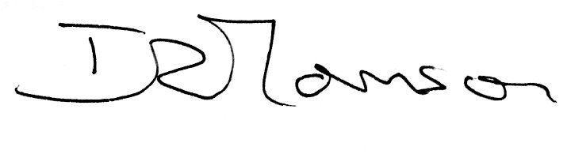

Role: Chairman of Trustees

Date: 12.3.24

|  |  |
| --- | --- |
| **DECLARATION OF INTERESTS of Trustees of the FAN Charity** | |
| Name of Trustee |  |
| Date appointed initially |  |
| Have you been disqualified from acting as a trustee in the past  (view the disqualifications table at <https://www.gov.uk/government/uploads/system/uploads/attachment_data/file/673797/Auto_disqualification_table_v1.1.pdf> for further information) | YES 🞏 (please detail below)  NO 🞏 |
| Do you consider you have any personal interests to declare which could compromise your independence when undertaking your role as Trustee? | YES 🞏 (please detail below)  NO 🞏 |
| Examples of personal interests can include:   * Related to a member of staff * Membership of any committee of another organisation that is competing for the same funding * Sharing in a business that may be awarded a contract to do work or provide services for the organisation or is a director, trustee, partner or employee or related to someone who is. | Declared Interests: |

I certify that I have read the Conflict of Interest Policy and confirm that interests which may compromise my independence and/or position are listed above. I agree that, in the event of any interest(s) arising after making this declaration, I will declare to Trustees any such interest(s) and will complete and submit a further Declaration of Interests form

Full Name of Trustee:

Signature*:*

Date*:*